**NOTE LOG**

### A MINI PROJECT REPORT

#### Submitted by

#### G22/T16

**GARIMA,2210990313,**

**GARIMA, 2210990314,**

**GARV SAINI,2210990315,**

**GARVIT SETIA, 2210990316**

in partial fulfillment for the award of the degree of

## BACHELOR OF ENGINEERING

***in***

COMPUTER SCIENCE & ENGINEERING



**CHITKARA UNIVERSITY**

**CHANDIGARH-PATIALA NATIONAL HIGHWAY**

**RAJPURA (PATIALA) PUNJAB-140401 (INDIA)**

###### TABLE OF CONTENTS

|  |  |  |
| --- | --- | --- |
| **Sr.no** | **Section** | **Page no** |
| 1. | Introduction | 3 |
| 2. | Problem Statement | 4 |
| 3. | Technical Details | 5 |
| 4. | Key Features | 8 |
| 5. | Project Advantages | 9 |
| 6. | Results | 10 |
| 7. | Conclusion and Future scope | 11 |
| 8. | References | 12 |

###### 1. INTRODUCTION *(Abstract)*

1. A Note log list is a list of tasks that need to be completed, typically organized in order of
2. priority. It is one of the simplest solutions for task management and provides a
3. minimal and elegant way for managing tasks a person wishes to accomplish.
4. Our aim is to design a simple and elegant website for people to keep a track of the
5. status of their tasks. Making a Note log list is an easy and important task that everyone
6. should do. The immense satisfaction that one gets when completing the task and
7. marking it on the list are incomparable. Moreover, creating a list of tasks ensure you
8. don’t miss out on anything. It’s a scientific fact that when you write the tasks that you
9. need to complete, you are even more motivated to complete it. With this in mind, we
10. come to build a platform which will help people create their own task list.
11. With the help of modern tools and technologies, we strive to build a minimal and
12. efficient Note log list which minimizes distractions and helps people achieve task
13. management with ease and without hassl

A Note log list is a list of tasks that need to be completed, typically organized in order of

priority. It is one of the simplest solutions for task management and provides a

minimal and elegant way for managing tasks a person wishes to accomplish.

Our aim is to design a simple and elegant website for people to keep a track of the

status of their tasks. Making a Note log list is an easy and important task that everyone

should do. The immense satisfaction that one gets when completing the task and

marking it on the list are incomparable. Moreover, creating a list of tasks ensure you

don’t miss out on anything. It’s a scientific fact that when you write the tasks that you

need to complete, you are even more motivated to complete it. With this in mind, we

come to build a platform which will help people create their own task list.

With the help of modern tools and technologies, we strive to build a minimal and

efficient Note log list which minimizes distractions and helps people achieve task

management with ease and without hassle

A Note log is a simple prioritized list of the tasks a person must complete. People make a list of everything they need to do, ranked according to priority from the most critical task at the top to the least critical task at the bottom. Note logs are quickly made entries of the tasks or the atomic entities.

To be sure, note log terminology like "Office meeting" or "buy new laptop" are frequently very short notes. Because the signal is so quick, it is only useful for a short period of time while the task is remembered. Note logs directly add to the person’s productivity system. The functionalities provided by a good Note log application help clear up the user’s mind as their pending tasks are recorded safely and they won’t be forgotten.

The Note log project is a user-friendly website which helps them to keep track of their tasks. It is a simple site which requires no sign-in/log-in or any personal details but still records your task, along with time, day and date the note is created, marks the completed tasks, and stores them even if you visit the site after a few days.

**3.PROBLEM STATEMENT**

Traditionally , notes are written on a piece of paper, or post-it notes and do act as memory aids. But as technology has evolved with time, we have been able to create notes using online notepads, applications, spreadsheets, word documents and many more. Note logs can be used in personal and professional life both , accessed anytime, anywhere with ease.

But sometimes many note making apps are not well organised and make it difficult to organise notes; sometimes notes are not properly synced which creates frustration among users , and the interface that is used is quite boring for the users.

Overall, there is a solution to above problem in the form of online note-making app that offers effective organisation, with time, day and date of entry of notes and an interesting interface to the user .

**3.TECHNICAL DETAILS**

**The Front-End technologies that are used to implement this project are:**

The Hypertext Markup Language or HTML is standard markup language for documents designed to be displayed in a web browser

* 1. **HTML-**

.

Use of HTML in project:

1. <html> represents the root of an HTML document.
2. <head> represents a collection of metadata for doc.
3. <meta> represents various kinds of metadata that can’t be expressed using title, base, link, style.
4. <title> represents document’s title or name
5. <link> allows authors to link their documents to other resources.
6. <body> represents contents of the documents.
7. <h1> represents a section heading
8. <style> allows for quick styling using CSS
9. <div> element is the generic container for flow content
10. <ul> represents unordered list.
11. <li> represents a list item.
12. <footer> creates footer for the sectioning content

CSS or cascading style sheets is used for styling and formatting HTML documents. It is used to define styles for HTML elements such as fonts, colors, spacing and layout.

**3.2 CSS -**

Use of CSS in project:

1. Inline and internal css has been used to give a proper layout to our website.
2. In adjustment of size and margin of images used using background-size, overflow, height, width, background-size , background-position, margin and more.
3. created an add bar and designed it in such a way that we are able to add our day to day task and also we created an add button using div in html.
4. Horizontal bar containing **All, Completed and Not Completed tasks** and used different font colors and font style.
5. created sticky notes and gave them a proper background image to it by adjusting it's size, margin, width, height, content, color,flex using css.



JavaScript is a programming language used to add interactivity and functionality to websites. It is commonly used to create dynamic effects, responsive and interactive web pages .

**3.3 JavaScript-**

.

Use of Javascript in project:

1. The code checks if there is any existing data in the local storage related to the items. If so, data is retrieved and considered an array, else new array is created.
2. When **enter** element is clicked, createItem() function is called.
3. The ceateItem() function function creates a new object with current timestamp and saves it to the local storage.
4. The ‘**activateEditListeners()**’ function assigns a click event listener to each button which shows the update controller and enables text area.
5. The ‘**activateCancelListeners()**’ function assigns a click event to cancel button which hides the update controller.
6. The ‘**activateSaveListeners()**’ function , calls updateItem() when clicked which updates the index of the array by saving the item.
7. The ‘**activateDeleteListeners()**’ function calls the deleteItem() function which removes the item.

Thus , it allows userd to add, edit, delete and save list items which are stored on browser’s local storage .

**3.4 VS CODE-**

Visual studio code is a free and open-source code editor developed by Microsoft and is designed for building and debugging web and cloud applications.

.

**4.KEY FEATURES**

4.1 ORGANISED NOTES: The webpage **NOTELOG** makes it easy for the

user to organize their notes orderly , with date, day and time of entries.

4.2 ACCESSIBILITY: Since notes are online, these can be available

Anywhere , anytime with ease.

4.3 EFFICIENT: Very few resources are required to store and run the   
 webpage.

4.4 EASY TO USE : The application provides an easy to use , user-

friendly interface which provides addition of notes, notepads, list all

the tasks together, sort completed and incomplete tasks in one-single

click.

4.5 FREE TO USE : The notelog application is completely free to use and

Can be used by anyone for any purpose (household / professional/

Business etc.

4.6 EAZY UPDATATIONS : The entries in the To-do list can be updated . easily with one-click.

**5. PROJECT ADVANTAGES**

* **The Benefits of Using a Note log List: -**
* **Improves your memory:** A note log list acts as an external memory aid. It’s only possible to hold a few pieces of information at one time. Keep a note log list and you’ll be able to keep track of everything, rather than just a few of the tasks you need to do. Your note log will also reinforce the information, which makes it less likely you’re going to forget something.
* **Increases productivity**: A note log list allows you to prioritize the tasks that are more important. This means you don’t waste time on tasks that don’t require your immediate attention. Your list will help you stay focused on the tasks that are the most important.
* **Helps with motivation**: note log lists are a great motivational tool because you can use them to clarify your goals. You can divide your long-term goal into smaller, more achievable short-term goals and as you tick each one off your list, your confidence will increase.

**6. OUTPUT**

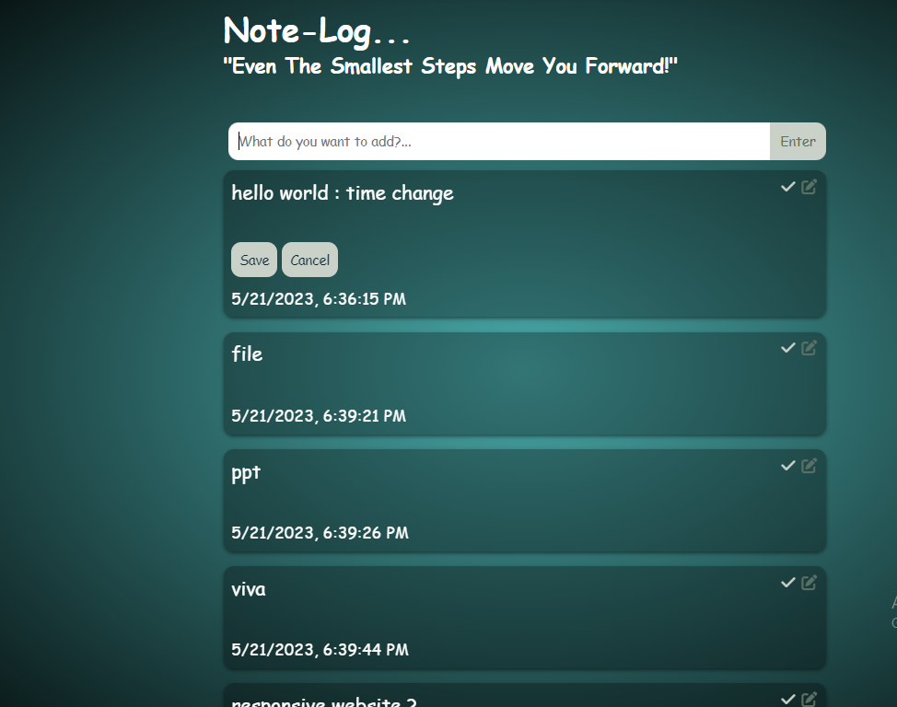

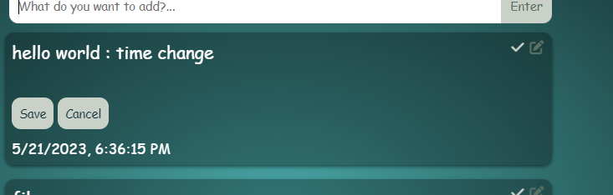

**7.Conclusion with Future scope**

* Improvement in security and integrity
* Integration with other applications such as calendar, mail, location etc.
* Adding features like storage of data, more convenient organization of user data, make the page more customized.
* Hosting the web application online to make it accessible to more users.

**8. REFERENCES**

1. https://en.wikipedia.org/wiki/HTML
2. www.w3 schools.com
3. https://www.javatpoint.com/css-tutorial
4. codingnepalweb.com